Year 8 Chemistry Test

Student Name: Sydney Thompson

Goals:

- Sydney can draw, describe and identify examples of solids, liquids and gases.
- Sydney can determine the volume being held in a measuring cylinder.
- Sydney can give the symbol/name for most of the first 20 elements
- Sydney can identify elements, compounds and mixtures.

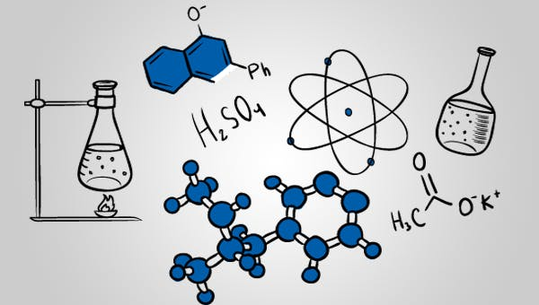

Teacher comment:

Question 1
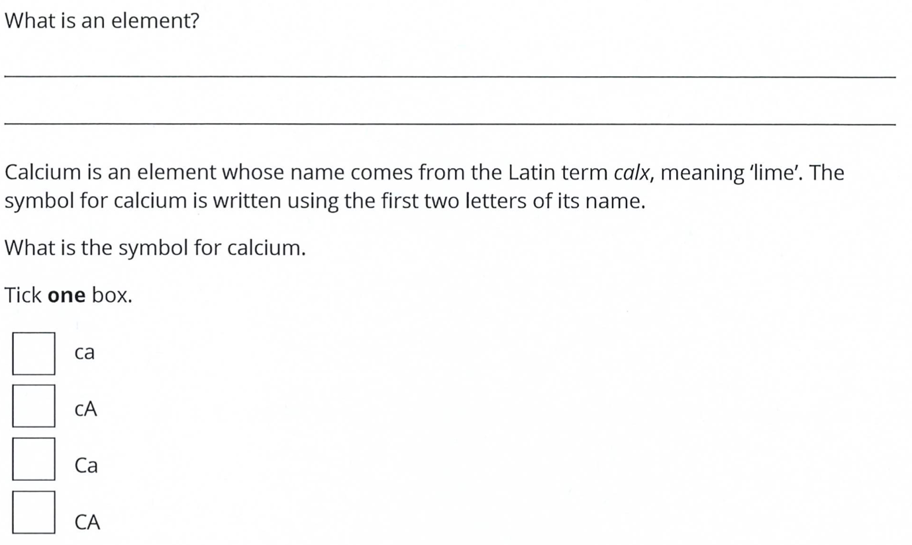

Question 2

Question 3

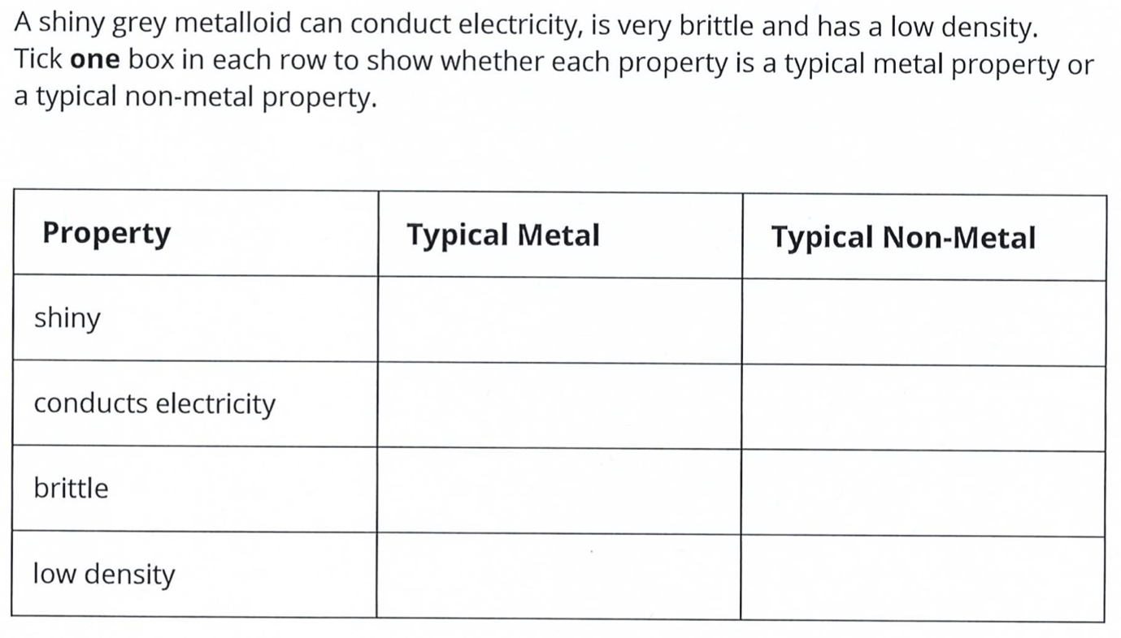

Question 4

Identify the change of state that is happening in each situation:

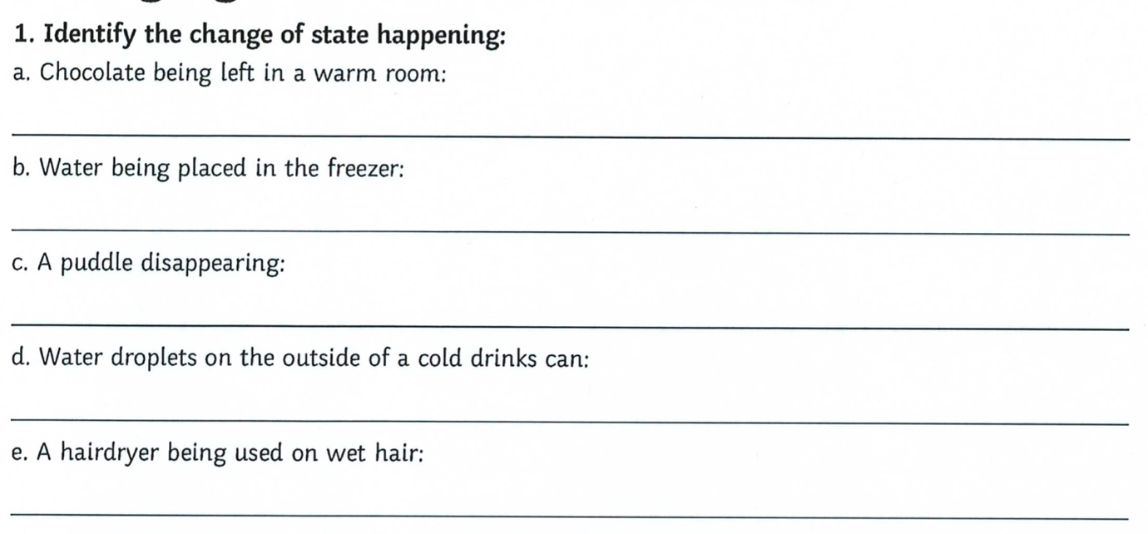

Question 5

In each box, write the change of state that is taking place:

Words:

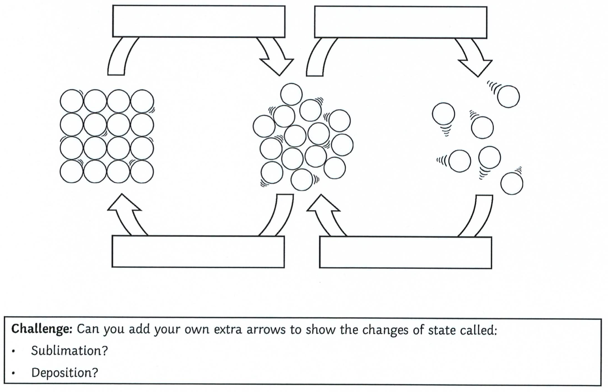

Question 6

For each property, explain why it is possible in terms of how the particles are arranged:

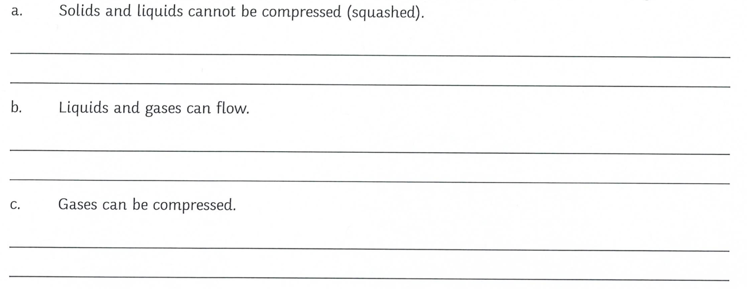

Question 7

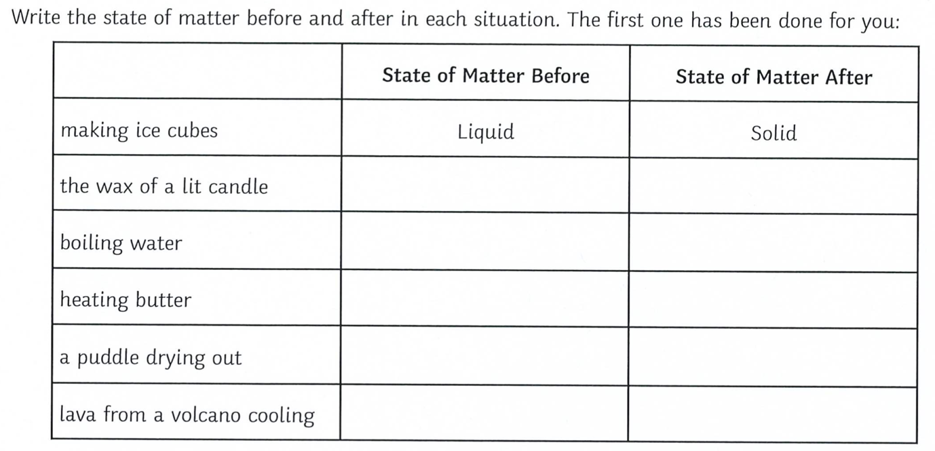

Question 8

- How many protons, neutrons and electrons do each of the following atoms have?

- For an extra challenge: Can you work out the atomic number and the atomic mass. Remember – the atomic number is number of protons in the nucleus, while the mass number is the number of protons plus the number of neutrons.

- Can you identify which elements each atom belongs to?

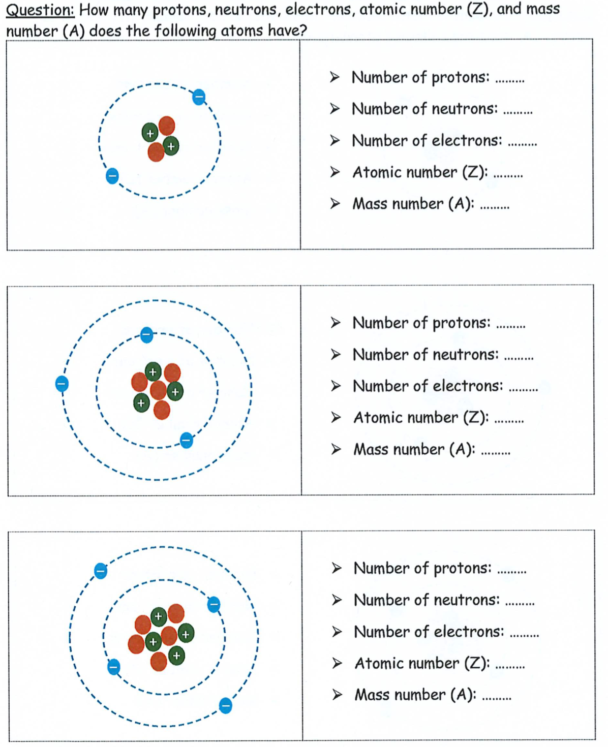

Question 9

Complete the table by giving the element name or symbol where appropriate.

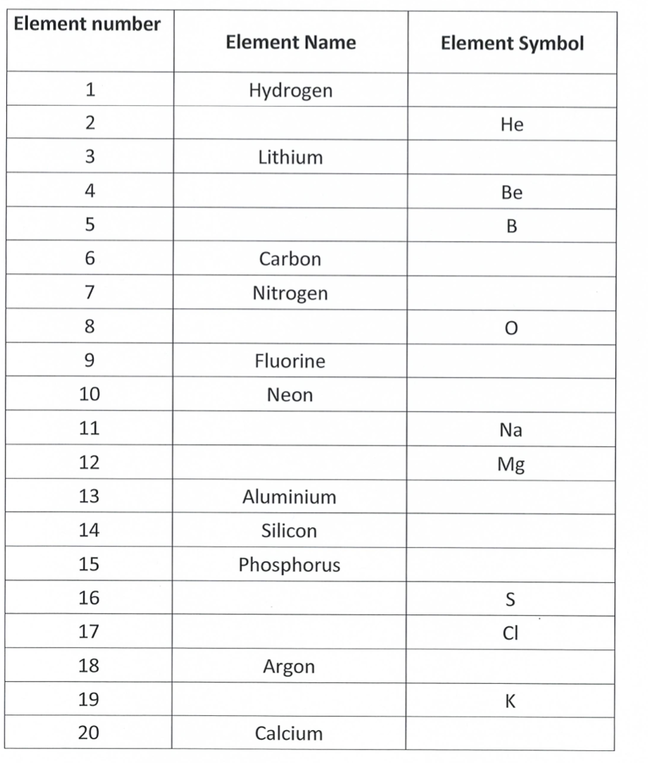

Question 10

For the following question, circle the correct box.

Which of the boxes contains:

a) Molecules of an element?
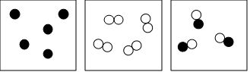

b) Molecules of a compound?
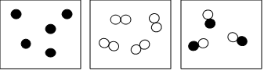

c) Atoms of an element?
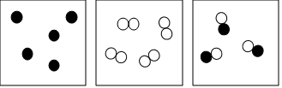

End of Test

